CSE 581

**Lab 3: Selects with Joins**

*Do this lab against the Northwind database.*

***For the entire lab, provide all of your SQL as text, inserted at the beginning of the document.***

***For each step also provide a screenshot of execution, showing the SQL and the results.***

***Please make sure both the SQL and the screenshots are marked w/ the question number that they are answering.***

**Steps:**

1. List all orders and their corresponding order details.

SELECT *

from [order details] od inner join Orders o

on od.orderid=o.Orderid;

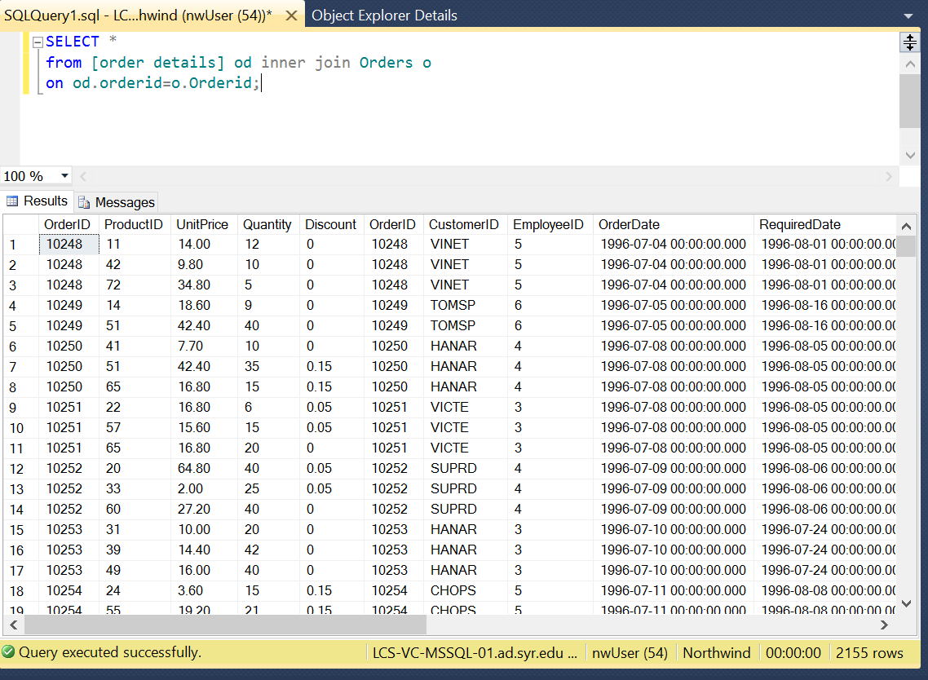

1. List all orders (OrderID) and matching customers (Company Name).

SELECT *

from orders o left outer join customers c

on o.customerid=c.customerid;

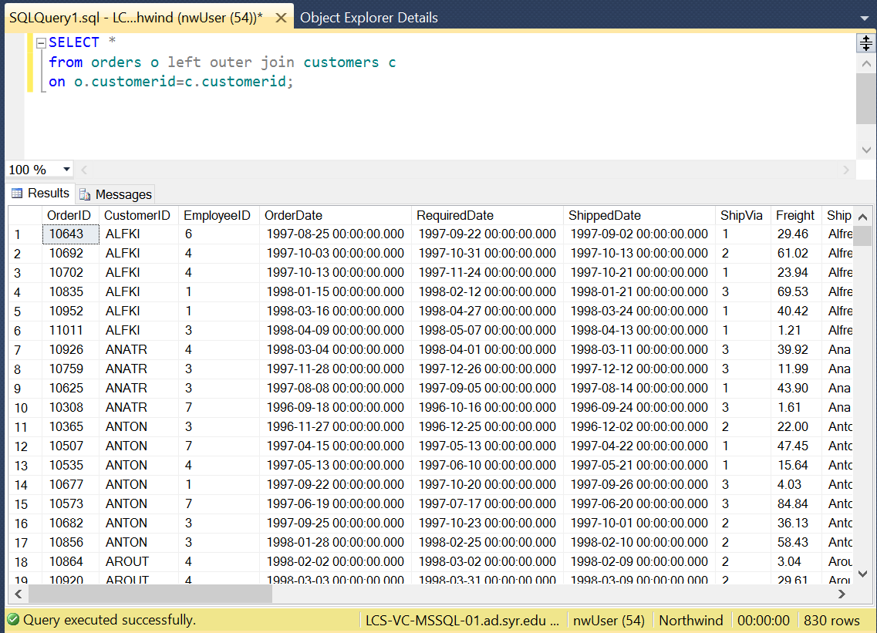

1. List orders (OrderID) and corresponding customers (Company Name), only where the records match up.

SELECT *

from orders o inner join customers c

on o.customerid=c.customerid;

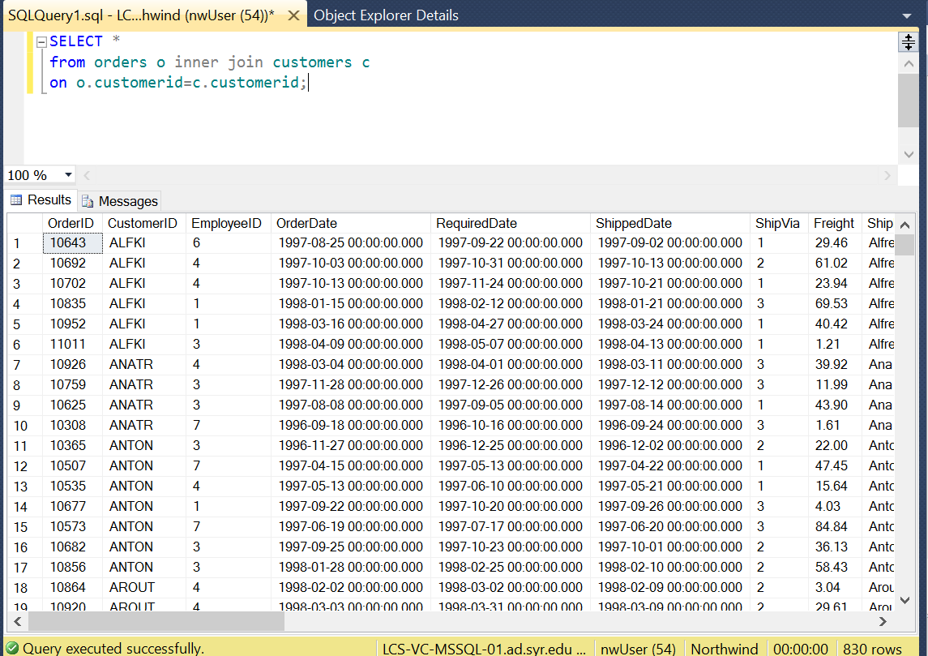

1. List all orders (OrderID) and all customers (Company Name), matching records appropriately.

SELECT *

from orders o full outer join customers c

on o.customerid=c.customerid;

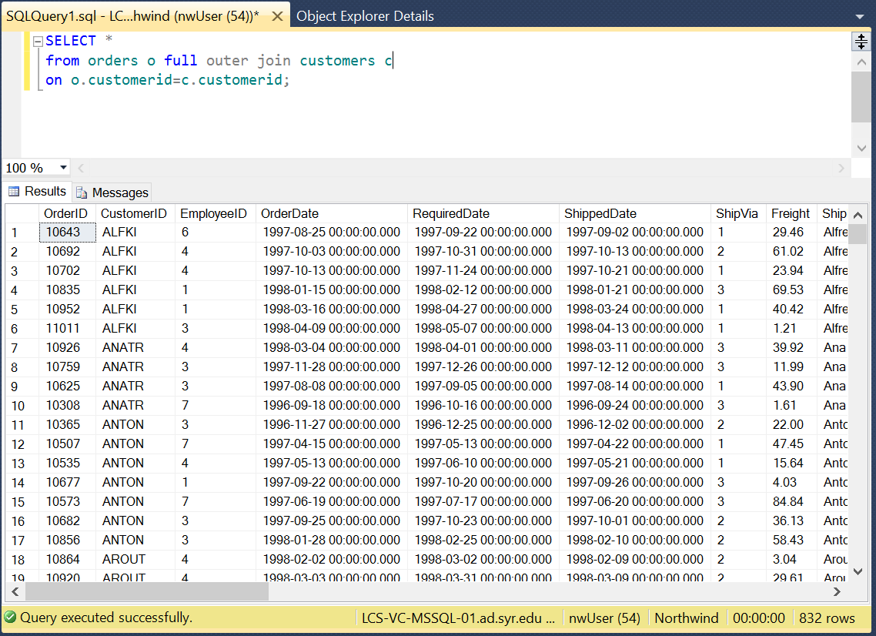

1. List matching orders (OrderID) and all customers (Company Name).

SELECT *

from orders o right outer join customers c

on o.customerid=c.customerid;

